**Assignment 1**

**Task 1: Installation of Windows 11**

**Installing Windows 11 on My PC**

**Step 1: Obtaining the OS**

* + Obtained a Windows 11 installation setup from a cyber guy, who provided it on a flash drive.
  + Inserted the flash drive containing the Windows 11 installation files into a USB port on my PC.

**Step 2: Booting from USB**

1. **Restart the PC:**
   * Restarted my PC to begin the installation process.
2. **Access BIOS/UEFI Settings:**
   * During startup, accessed the BIOS or UEFI firmware settings by pressing the designated key (often F2, F12, Esc, or Del) depending on the motherboard manufacturer.
3. **Set Boot:**
   * Navigated to the Boot menu in BIOS/UEFI settings.
   * Selected the USB flash drive as the primary boot device to boot from.
   * Saved the changes and exited BIOS/UEFI settings, allowing the PC to restart and boot from the Windows 11 installation media.

**Step 3: Install Windows 11**

1. **Windows Setup Begins:**
   * The PC booted from the USB flash drive, initiating the Windows 11 setup process.
2. **Choose Language and Region:**
   * Selected preferred language, time, and keyboard input method.
3. **Click "Install Now":**
   * Clicked on the "Install Now" button to start the Windows 11 installation.
4. **Enter Product Key (if required):**
   * Entered the product key if prompted. For some installations, this step might be skipped if Windows 11 is activated digitally.
5. **Accept License Terms:**
   * Read and accepted the Microsoft Software License Terms to proceed with installation.
6. **Select Installation Type:**
   * Chose the installation type (e.g., Custom for a clean installation or Upgrade to keep files and settings).
7. **Partition and Install:**
   * Selected the disk partition where Windows 11 will be installed.
   * Clicked "Next" to begin the installation process. Windows 11 copied files, installed features, and updated settings.

**Step 4: Complete Installation**

1. **Restart and Configure:**
   * The PC automatically restarted several times during installation.
   * Configured basic settings like region, account preferences, and network connectivity.
2. **Set Up User Account:**
   * Created a user account and set a password for logging into Windows 11.
3. **Personalize Windows 11:**
   * Personalized Windows 11 settings such as desktop background, theme, and privacy options.

**Task 2: Installation of VS code**

**Step 1: Download Visual Studio Code**

1. **Visited the Official Website:**
   * I opened my web browser and went to the Visual Studio Code website.
   * On the homepage, I saw download links for different operating systems. I clicked on the download button labeled "Windows" to download the installer for Windows.

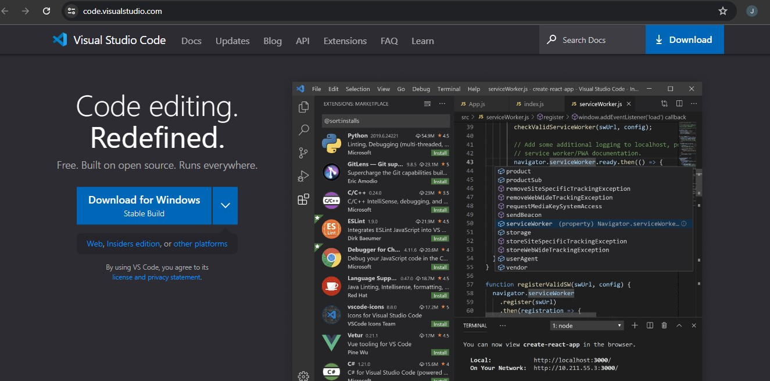

**Step 2: Installation of Visual Studio Code on my Windows**

1. **Run the Installer:**
   * After the download was complete, I navigated to my Downloads folder and double-clicked on the VSCodeSetup.exe file to run the installer.
2. **Accept the License Agreement:**
   * A setup window appeared. I read through the license agreement, checked the box to accept the terms, and clicked the Next button.
3. **Choose Installation Location:**
   * The installer prompted me to choose the destination folder for the installation. I decided to go with the default path and clicked Next.
4. **Select Additional Tasks:**
   * Next, I was asked to select additional tasks. I checked the following options to enhance my experience:
     + Create a desktop icon
     + Add "Open with Code" action to Windows Explorer file context menu
     + Add "Open with Code" action to Windows Explorer directory context menu
     + Register Code as an editor for supported file types
   * After selecting these options, I clicked Next.
5. **Install:**
   * I reviewed the installation settings one last time and then clicked the Install button to start the installation process.
6. **Launch Visual Studio Code:**
   * Once the installation was complete, I checked the box that said Launch Visual Studio Code and clicked Finish.

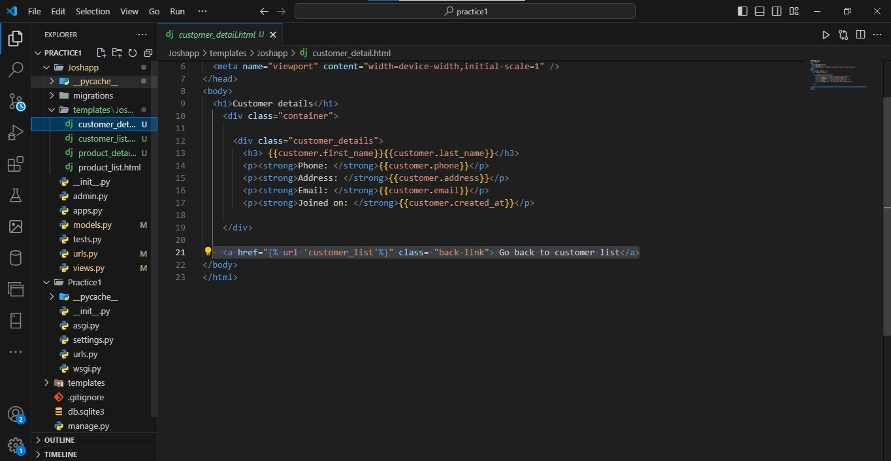

**Step 3: Setting Up Extensions.**

I went ahead and installed some crucial extensions.

1. **Open VS Code:**
   * Visual Studio Code launched automatically. If it didn't, I could open it by clicking the VS Code icon on my desktop or finding it in the Start Menu.
2. **Install Extensions:**
   * Inside VS Code, I clicked on the Extensions icon in the Activity Bar on the side of the window or pressed Ctrl+Shift+X.
   * I searched for the extensions I needed, such as Python which we began with.

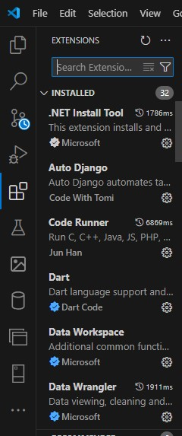

**Task 3: Installation of Git**

**Step 1: Installation of Git**

1. **Download Git:**
   * I opened my web browser and went to the Gti website to download the Windows installer.
2. **Run Installer:**
   * I double-clicked the downloaded *Git-2.x.x-64-bit.exe (My pc version)* file and followed the prompts, accepting all defaults.

**Step 2: Configure Git**

1. **Open Git Bash:**
   * I searched for Git Bash in the Start Menu and opened it.
2. **Set Username and Email:**
   * In Git Bash, I ran the following commands to configure my Git username and email:

git config --global user.name "Joshua"

git config --global user.email “[joshuamomanyi2323@gmail.com](mailto:joshuamomanyi2323@gmail.com) “

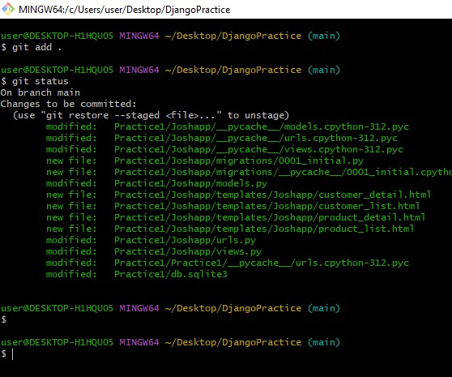

**Create GitHub Account**

1. **Sign Up:**
   * I went to the [GitHub website](https://github.com/), clicked on the Sign up button, followed the prompts to create a new account, and verified my email.

**Step 4: Initialize Repository and Commit**

1. **Open Git Bash in Project Directory:**
   * I navigated to my project folder in Windows Explorer, right-clicked inside the folder, and selected Git Bash Here.
2. **Initialize Repo:**
   * In Git Bash, I ran: git init
3. **Add Files:**
   * To stage all files, I ran: git add.
4. **Commit Files:**
   * To make the first commit, I ran: git commit -m "Initial commit"

**Task 4: Installation on python**

**Step-by-Step Guide to Installing Python on Windows**

**Step 1: Download Python Installer**

1. **Visited the Python Website:**
   * I opened my web browser and navigated to [python.org](https://www.python.org/).
2. **Navigated to Downloads:**
   * Clicked on the "Downloads" tab at the top of the page to access the Python download section.
3. **Chose Python Version:**
   * Selected the latest stable version of Python by clicking on the big yellow button labeled "Download Python x.x.x".
   * Ensured to choose the appropriate installer based on my system architecture (64-bit or 32-bit). I opted for the 64-bit version for my Windows system.

**Step 2: Ran the Python Installer**

1. **Ran the Installer:**
   * Once the installer file (python-x.x.x-amd64.exe) finished downloading, I navigated to my Downloads folder (or the location where the file was saved).
2. **Started Installation:**
   * Double-clicked on the installer file to launch the Python installer. This action prompted a User Account Control (UAC) dialog; I clicked "Yes" to allow the installer to proceed.
3. **Configured Python Installation:**
   * In the Python Installer window that opened:
     + Ensured the checkbox labeled "Add Python x.x to PATH" was checked. This ensured Python was easily accessible from the Command Prompt.
     + For customization, I clicked on "Customize installation" to modify the installation location or select additional features if necessary. However, I proceeded with the default settings for simplicity.
4. **Began Installation:**
   * Clicked on the "Install Now" button to start the installation process. The installer displayed a progress bar indicating the installation status.

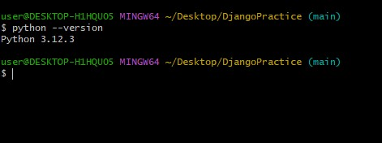

#### Task 5: pip – installation

#### Download get-pip.py

1. **Download get-pip.py:**
   * Visited [python.org](https://www.python.org/) and searched for "get-pip.py".
   * Downloaded get-pip.py from the official page.

#### Step 3: Install Pip

1. **I right clicked and ran Command Prompt as Administrator:**
2. **Navigated to the folder containing get-pip.py in Command Prompt:**
3. Install pip by running: python get-pip.py
4. **Verify pip Installation:**

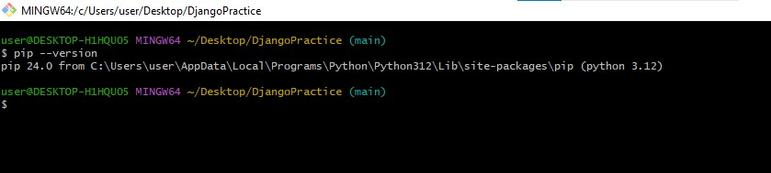

**Task 6: Installation and Configuration of my SQL**

**Installing and Configuring MySQL on Windows**

**Step 1: Download MySQL Installer**

1. **Visit MySQL Website:**
   * Opened my web browser and navigated to MySQL Community Downloads.
2. **Select MySQL Edition:**
   * Chose MySQL Community Server as it is suitable for most development and production environments.
3. **Download MySQL Installer:**
   * Clicked on the "Download" button for MySQL Community Server appropriate for Windows.

**Step 2: Run MySQL Installer**

1. **Launch MySQL Installer:**
   * Located the downloaded installer file in my Downloads folder.
   * Double-clicked the installer file to launch the MySQL Installer setup wizard.
2. **Choose Setup Type:**
   * Opted for a "Custom" setup to configure MySQL components.
   * Clicked "Next" to proceed with the installation.

**Step 3: Configure MySQL Server**

1. **MySQL Server Configuration:**
   * Selected "Custom" setup type to customize features later if needed.
   * I selected MySQL Server and Workbench during installation phase.
   * Configured MySQL Server:
     + Set port number (default 3306).
     + Chose strong password authentication for security.
2. **Configure MySQL as a Windows Service:**
   * Selected to configure MySQL Server as a Windows service for automatic startup.
   * Specified service name and used the default System Account for simplicity.
3. **Apply Configuration Settings:**
   * Clicked "Next" to apply the chosen configuration settings and initiate MySQL Server setup.
4. I then proceeded to install MySQL Workbench.